Darpan kewalramani

Task 1:

Develop and Deploy any simple web application on cloud platfrom like

AWS , Azure or Google cloud etc.

Create Aws account

Login Aws

Steps 1:

First Create S3 buket

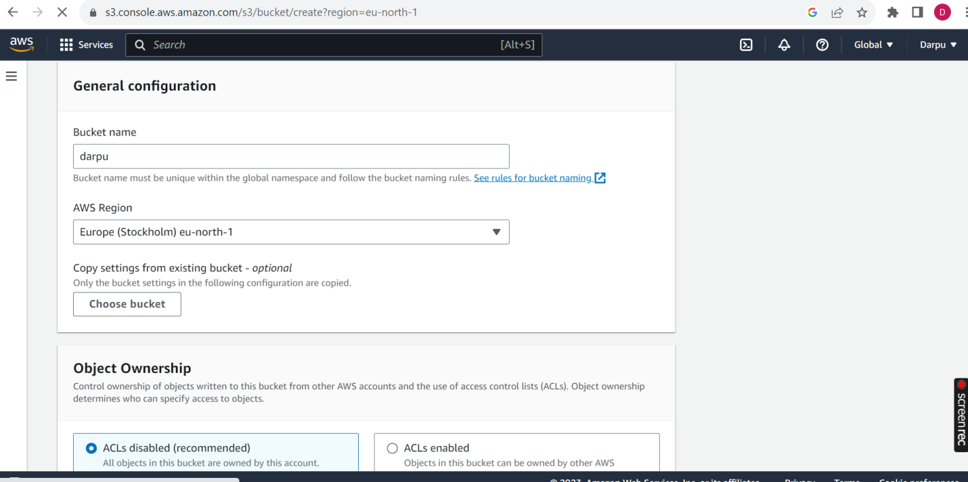

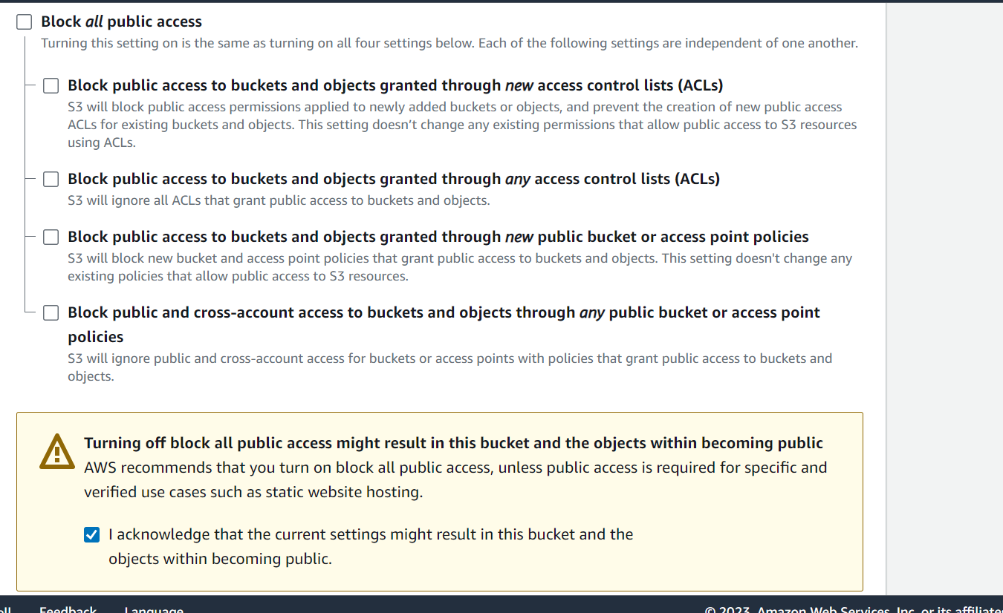

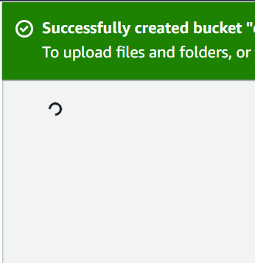

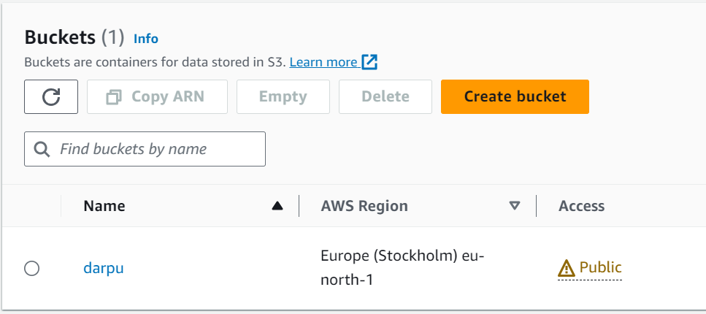

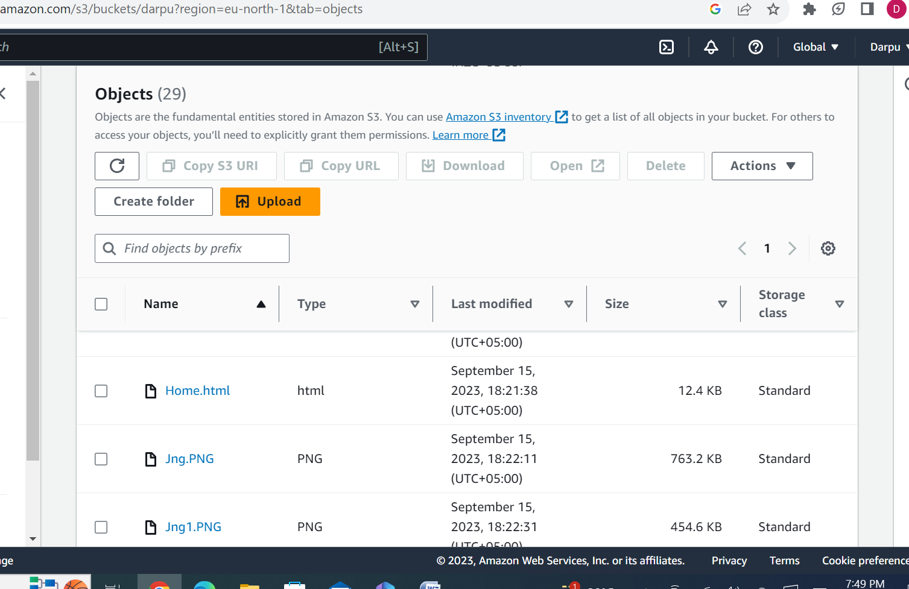

Step2:

Go to permission Edit Policy generator

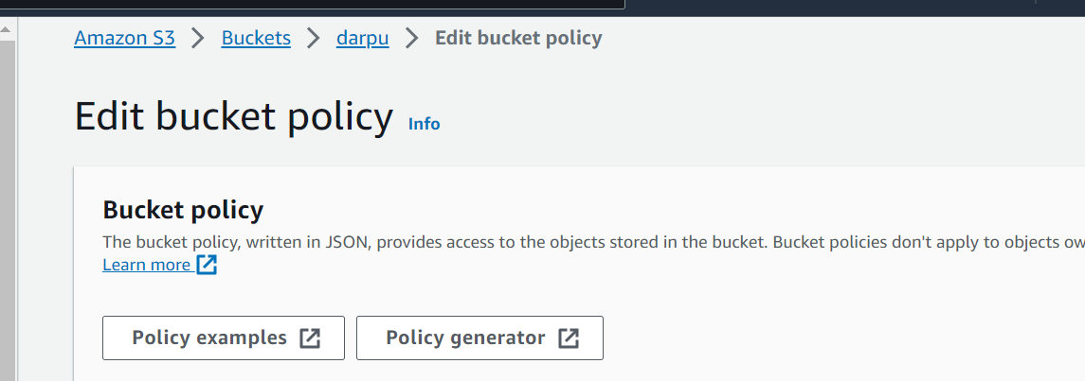

Step 3:

Go to properties Edit Static Website hosting

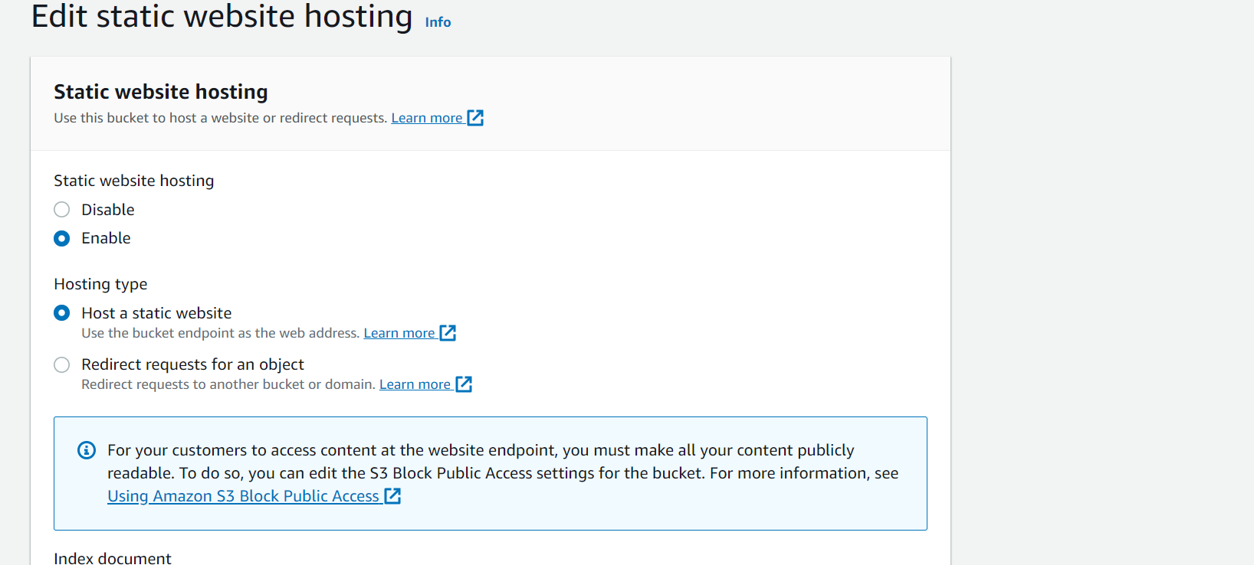

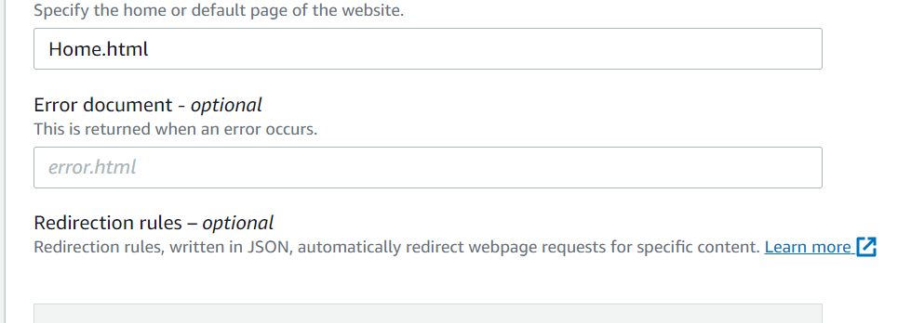

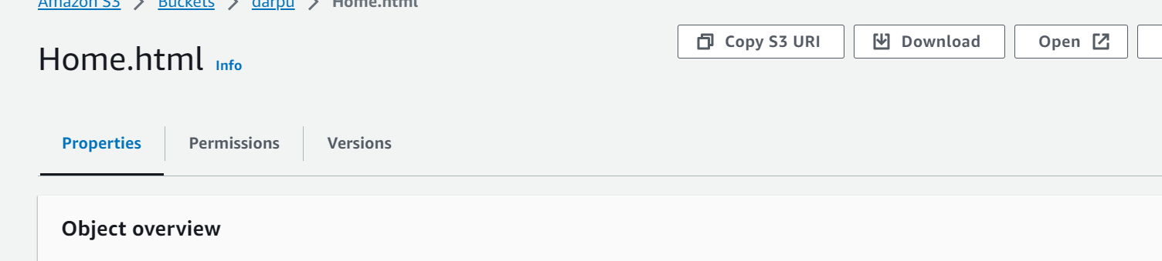

Step 4:

Click On URL (Website will be open)

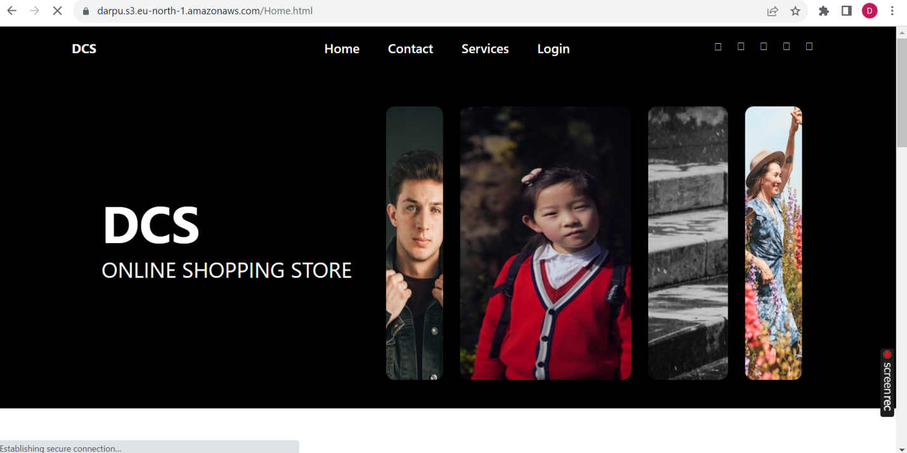

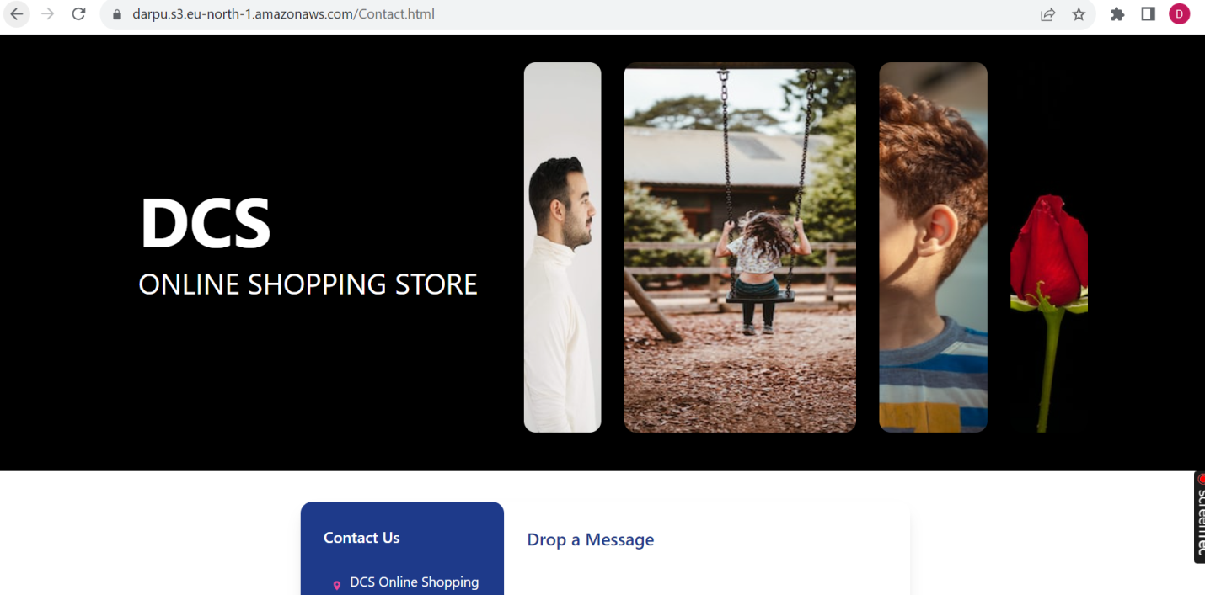

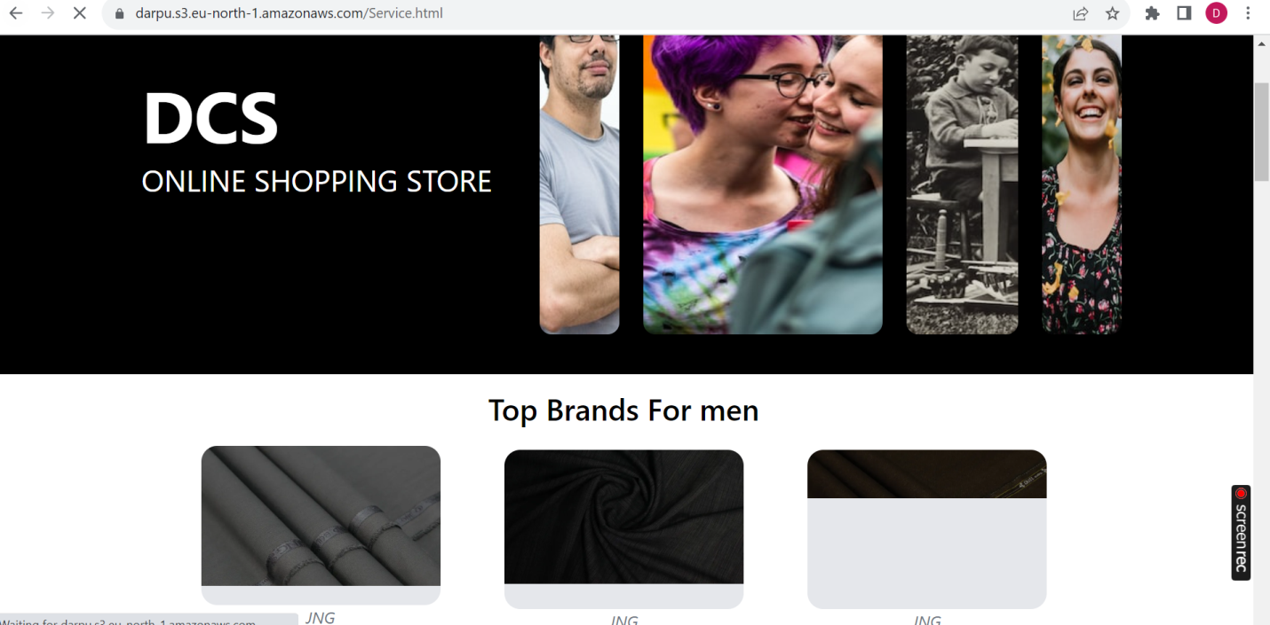

Upload Linkedin Video Upload on url here:

https://www.linkedin.com/posts/darpan-kewalramani-1b219922b_internsavy-aws-ec2-activity-7108458023672512513-t99n?utm_source=share&utm_medium=member_desktop